**Admin use case diagram:**

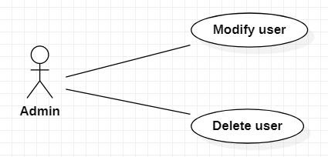

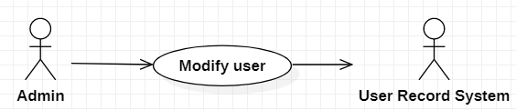

|  |  |
| --- | --- |
| Modify User | |
| Actors | Admin, User Record System. |
| Description | Admin send the updated user to the user record system with the command that update this user with new information from database . |
| Data | Id, user name, phone, address,… |
| Stimulus | Interface that including user information and modify button. |
| Response | Message that: Update successful or fail( kind of error). |
| Comments | Admin must have permission to delete user. |